S, A. (2022). Item manuscript template. International technology and education journal, 6(1), 83-94.
ITEJ Manuscript Template (16 pt.)
First Author, epostafirst@eposta.com, Institution, Country, https://orcid.org/orcid-id (10 pt.)
Second Author, epostasecond@eposta.com, Institution, Country, https://orcid.org/orcid-id (10 pt.)
SUMMARY (10 pt.)
Page Layout: A4 Vertical, Font Family: Times New Roman. The instruction for the preparation of ITEJ manuscript can be seen in this template. Use of the template will save time during the production of your publication. The instruction for the preparation of ITEJ manuscript can be seen in this template. Use of the template will save time during the production of your publication. The instruction for the preparation of ITEJ manuscript can be seen in this template. Use of the template will save time during the production of your publication. The instruction for the preparation of ITEJ manuscript can be seen in this template. Use of the template will save time during the production of your publication. The instruction for the preparation of ITEJ manuscript can be seen in this template. Use of the template will save time during the production of your publication. The instruction for the preparation of ITEJ manuscript can be seen in this template. Use of the template will save time during the production of your publication. The instruction for the preparation of ITEJ manuscript can be seen in this template. Use of the template will save time during the production of your publication. (10 pt.)
Keywords: Keyword1, keyword2, keyword3 (10 pt.)
INTRODUCTION (UPPERCASE, 10 pt.)
Manuscripts should be prepared in Microsoft Word format. . If you have any questions, please contact the editor via info@itejournal.com The publisher and journals have a zero-tolerance plagiarism policy. We check the manuscrpts using iThenticate plagiarism prevention tool and reviewer check. All submissions will be checked by iThenticate before sending to reviewers (Authorx & Authory, 2018).
Manuscripts should be prepared in Microsoft Word format. . If you have any questions, please contact the editor via info@itejournal.com The publisher and journals have a zero-tolerance plagiarism policy. We check the manuscrpts using iThenticate plagiarism prevention tool and reviewer check. All submissions will be checked by iThenticate before sending to reviewers.
Subtitle (if exists, 10 pt.)
When you submit a manuscript, the editor or editorial assistant will send a confirmation email to the submission’s author within one to three working days. If you fail to receive this confirmation email, please check your spam email box or contact the editorial assistant.
Table 1. Teachers’ Opinions
 | Group | Number | Percentage
All teachers | Approve | 584 | 59.4
 | Disapprove | 1431 | 40.6
As shown in Table 1, … When you submit a manuscript, the editor or editorial assistant will send a confirmation email to the submission’s author within one to three working days. If you fail to receive this confirmation email, please check your spam email box or contact the editorial assistant.
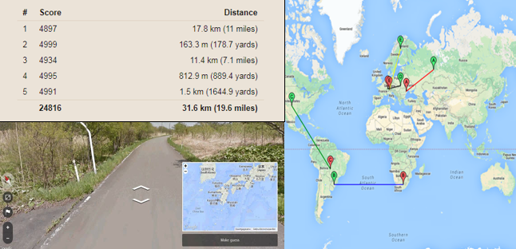
Figure 1. Game screenshots
As shown in Figure 1, …
METHOD (UPPERCASE, 10 pt.)
We use a double-blind system for peer review. Both reviewers’ and authors’ identities will remain anonymous. We use a double-blind system for peer review. Both reviewers’ and authors’ identities will remain anonymous. We use a double-blind system for peer review. Both reviewers’ and authors’ identities will remain anonymous. We use a double-blind system for peer review. Both reviewers’ and authors’ identities will remain anonymous.
FINDINGS (UPPERCASE, 10 pt.)
The decision to accept or reject a manuscript is based on the views of reviewers. The decision to accept or reject a manuscript is based on the views of reviewers. The decision to accept or reject a manuscript is based on the views of reviewers. The decision to accept or reject a manuscript is based on the views of reviewers. The decision to accept or reject a manuscript is based on the views of reviewers. The decision to accept or reject a manuscript is based on the views of reviewers.
CONCLUSION AND DISCUSSION (UPPERCASE, 10 pt.)
The result of the review will be sent to the corresponding author. The result of the review will be sent to the corresponding author. The result of the review will be sent to the corresponding author. The result of the review will be sent to the corresponding author. The result of the review will be sent to the corresponding author. The result of the review will be sent to the corresponding author.
REFERENCES (UPPERCASE, 10 pt.)
APA 6 References.

